PONCA TRIBE OF NEBRASKA
Department of Education

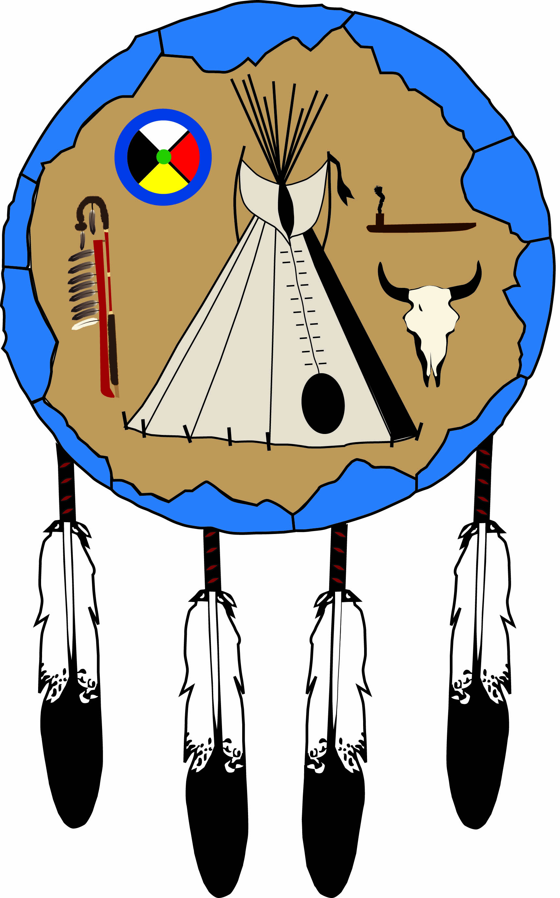

HIGHER EDUCATION
ADULT VOCATIONAL TRAINING
GRADUATE/POST-GRADUATE
APPLICATION

Application Deadlines Are As Followed:

Fall: August 15; Winter Quarter: November 15; Spring: December 15; Summer: May 15

Pages 5 and 10 are needed by the deadline, NO EXCEPTIONS!!

Adopted by Tribal Council
April 21, 1997

PONCA TRIBE OF NEBRASKA
Table of Contents

Required Forms and Deadlines Page 3
Student Checklist Page 4
Application Page 5
Standard Procedures Page 6
General Information/Guidelines……………………Pages 7-9
Contract of Understanding……………………………Page 10
Certification of Indian Blood (CIB)…………………Page 11
Financial Need Form (FNF)……………………………Page 12

Please complete and return all relevant pages of this packet to:
Ponca Tribe of Nebraska
Department of Education
1800 Syracuse Avenue
Norfolk, NE 68701

NOTE: Only the Financial Need Form (FNF)—page 12 of this
packet—must be submitted to our office by your school’s Financial
Aid Officer (FAO). As the student, you complete the top portion of
this form, and the school’s Financial Aid Officer (FAO) is to complete
the bottom portion. However, before the Financial Aid Officer (FAO)
can complete the bottom section of this form, the results of your
Free Application for Federal Student Aid (FAFSA) must be known.
The only instances where a FAFSA is not required are the following:
(1) short-term certification/licensure programs that are not PELL
eligible and (2) graduate programs—although not a PELL eligible
program, an assessment of need must still be determined so any
relevant areas, including an Expected Family Contribution (EFC)
must be indicated.

PONCA TRIBE OF NEBRASKA
Required Post-Secondary Forms

1. APPLICATION – A completed Higher Education/Adult Vocational
Training/Graduate/Post-Graduate Application.

2. CERTIFICATION OF INDIAN BLOOD - Original with official
seal to verify legal enrollment with the Ponca Tribe of Nebraska.

3. CONTRACT – Signed and dated for the relevant year in which
assistance is being requested.
4. FINANCIAL NEED FORM (FNF) - Students must complete the
Free Application for Federal Student Aid (FAFSA) package in
accordance with the institution’s financial aid policy. The FNF must
be submitted to the school’s Financial Aid Office every academic year
and each summer term. Upon completion of the FNF, the school will
then forward this form to the Tribe’s Department of Education.

5. LETTER OF ADMISSION (LOA) - Undergraduate and graduate
students must be OFFICIALLY and FULLY admitted to a post-
secondary institution which is accredited by one of the six (6) regional
accreditation agencies as recognized by the Ponca Tribe of Nebraska.
The graduate applicant shall submit a Letter of Acceptance from the
graduate program of study and a Letter of Acceptance from the
graduate university. The completed Financial Need Form may also
function in lieu of this letter.

6. TRANSCRIPTS - GED/high school/college transcripts. All first-year
students must submit either a copy of their GED/high school transcript/
diploma. On-going students must submit official copies of their college
transcripts for the most recent term funded.

DEADLINES

Fall Quarter/Semester: Application (p5)/Contract (p10) . . . . . . . . . . . . . August 15
FNF/CIB/Transcript . . . . . . . . . . . . . . . As soon as possible

Winter Quarter: Application (p5)/Contract (p10) . . . . . . . . . . November 15
FNF/CIB/Transcript . . . . . . . . . . . . . . . As soon as possible

Spring Quarter/Semester: Application (p5)/Contract (p10) . . . . . . . . . . December 15
FNF/CIB/Transcript . . . . . . . . . . . . . . . As soon as possible

Summer Session: Application (p5)/Contract (p10) . . . . . . . . . . . . . . . May 15
FNF/CIB/Transcript . . . . . . . . . . . . . . . As soon as possible

Financial Aid and
Application Process

Student Checklist

Date Sent Date Due What Where

1.______ January 31 Pell Grant form Processing Center
2.______ August 15 (F) Letter of Admission Ponca Tribe
November 15 (W) (suggested but not of Nebraska
December 15 (Sp) required)
May 15 (Sum)

3.______ March 1 (F) Student Aid Report School FAO August 15 (W/Sp)

4.______ August 15 (F) Tribal Application Ponca Tribe
November 15 (W) (page 5) and of Nebraska
December 15 (Sp) Contract (page 10)
May 15 (Sum)

5.______ As soon as Transcript Ponca Tribe
available of Nebraska

6.______ Aug 15 (F) School sends Ponca Tribe
Nov 15 (W) Financial Need of Nebraska
Dec 15 (Sp) Form
May 15 (Sum)
(dates suggested but
not required)

7.______ Tribe’s first Tribal Grant/ Award sent
Accounts Payable Award directly to
once student’s file school
is complete

(F) = Fall Semester; (W) = Winter; (Sp) = Spring Semester; (Sum) = Summer Session

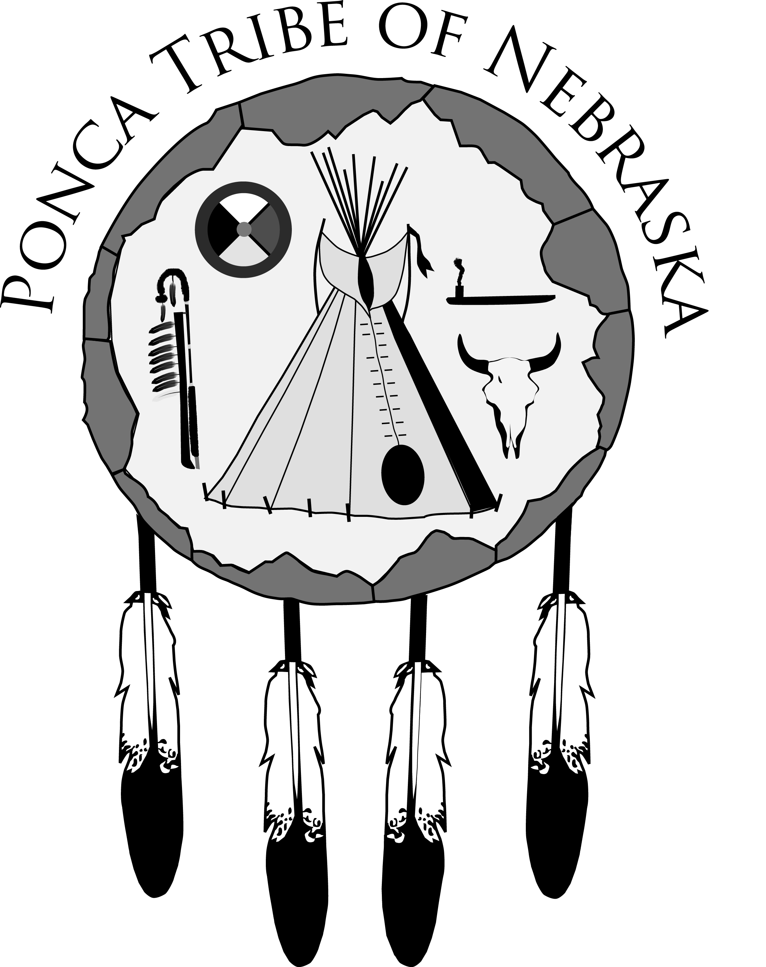PONCA TRIBE OF NEBRASKA | TERMS APPLYING FOR
DEPARTMENT OF EDUCATION | 20_____ FALL | 20_____SPRING
1800 SYRACUSE AVENUE | 20_____WINTER | 20_____SUMMER
NORFOLK, NE. 68701
PHONE: 402-371-8834 FAX: 402-371-7564
EMAIL: pate@poncatribe-ne.gov or aknudsen@poncatribe-ne.gov
HIGHER EDUCATION/ADULT VOCATIONAL TRAINING/
GRADUATE/POST-GRADUATE APPLICATION

Name: _______________________________________________________________________________
Last First Middle Maiden
Address: ______________________________________ Telephone:_____________________________
Street (Area Code)
_____________________________________________________________________________________
City State ZIP Email Address (Optional)
Social Security Number: ________________________ Date of Birth:_____________________
Tribal Enrollment Number: __________________________ Sex: Male Female

DEPENDENT STUDENT INDEPENDENT STUDENT (ACCORDING TO FEDERAL
GUIDELINES, STUDENTS THROUGH THE AGE OF 24 ARE GENERALLY CONSIDERED DEPENDENT WHETHER OR NOT THEY RESIDE WITH THEIR PARENTS.); IF INDEPENDENT, PLEASE CHECK ONE OF THE FOLLOWING:
SINGLE MARRIED SEPARATED DIVORCED WIDOWED
I HAVE COMPLETED (CIRCLE ONE) HIGH SCHOOL/GED. DATE OF COMPLETION:_________________
(BE SURE TO INCLUDE A COPY OF YOUR HIGH SCHOOL/GED TRANSCRIPT WITH YOUR APPLICATION.)
SCHOOL YEAR FOR WHICH FUNDING IS REQUESTED: 20_________ - 20_________
I AM APPLYING FOR THE ACADEMIC YEAR FALL WINTER SPRING SUMMER
I WILL BE ATTENDING FULL-TIME PART-TIME—IF PART-TIME, NUMBER OF CREDIT
HOURS? _________ TYPE OF TERM APPLYING FOR: SEMESTER QUARTER TRIMESTER

NAME AND CITY/STATE OF COLLEGE SELECTED: _____________________________________________
THIS IS A (CIRCLE ONE) TWO-YEAR/FOUR-YEAR COLLEGE? OTHER:______________________________
COLLEGE MAJOR___________________________EXPECTED DATE OF GRADUATION _______________
EXPECTED DEGREE: AA/AS/AAS BA/BS MA/MS OTHER _____________________________
YEAR IN COLLEGE: 1ST 2ND 3RD 4TH GRADUATE/POST-GRADUATE
I WILL LIVE: ON CAMPUS OFF CAMPUS WITH PARENTS.

HAVE YOU EVER RECEIVED A PONCA TRIBE OF NEBRASKA EDUCATIONAL GRANT BEFORE?
(CIRCLE ONE) YES/NO. IF YES, WHAT SCHOOL YEARS?____________________________________
NO. OF SEMESTER HOURS EARNED:___________ NO. OF QUARTER HOURS EARNED:__________

I declare that I will use any funds I receive through the Ponca tribe of Nebraska solely for expenses related to my attendance at the above, named college. I further declare that the information submitted as part of the application process is correct to the best of my knowledge, and I give consent to the release of any relevant information to necessary agencies in the completion of my financial aid package. In addition, I will arrange to have an official copy of my grade transcript sent to the Ponca tribe of Nebraska department of education at the end of each academic term. I also grant the tribe’s education department permission to request an official enrollment certificate from the tribe’s enrollment department to verify my eligibility as a tribal member and to update my address with enrollment if I should relocate.

_________________________________________________________________________ ______________________
Signature of Student Date

Ponca Tribe of Nebraska
Standard Procedures

Hereinafter, the Ponca Tribe of Nebraska GRANT program shall be called the
PROGRAM and the student applicant shall be called the GRANT RECIPIENT.

ALL APPLICANTS SHALL:

1. Complete and submit a Ponca Tribe of Nebraska grant
application by August 15 for Fall semester, November 15 for
Winter Quarter, December 15 for Spring Quarter/Semester, and
May 15 for summer term.

2. Submit an official Certification of Indian Blood (CIB) by using
the same dates indicated in #1.

3. Submit a copy of the Letter of Admission (LOA) from an
accredited college/university/tech school or graduate school
and degree program also using the same dates as those
indicated in #1. However, the signature of the Financial Aid
Officer on the Financial Need Form (page 12 of this packet)
may serve as a substitute for the Letter of Admission.

4. All first-time applicants must submit copies of their GED/high
school diploma/transcripts. All first-time applicants and all
continuing GRANT RECEPIENTS must submit an official
college transcript within 15 days after the end of each term.

5. The Completed Financial Need Form (FNF) is to be forwarded
to our office by the school’s Financial Aid Office. This form
should be received at the same time as the application.

THE GRANT RECIPIENT:

1. The GRANT RECIPIENT shall abide by and comply with
the specific policies, procedures, and eligibility requirements of
the PROGRAM. The GRANT RECIPIENT shall be responsible
for understanding his/her rights and responsibilities regarding
financial assistance including the responsibility to be informed
of program policies.

2. The GRANT RECIPIENT shall sign the application for financial
assistance with the stated terms, conditions, and standards.

3. The GRANT RECIPIENT shall release his/her official academic
grades, graduation date, academic major and type of degree
being pursued.

4. The GRANT RECIPIENT shall immediately report any change
in marital status, name, income, enrollment, withdrawal, and/or
transfer status to the PROGRAM. The GRANT RECIPIENT
who misuses said funds shall be denied additional financial
assistance awards for one (1) academic year and shall repay
the amount of misused funds.

5. The GRANT RECIPIENT shall notify the PROGRAM of
his/her graduation date, certificate or degree to be conferred,
and submit a final grade transcript upon graduation.

6. The GRANT RECIPIENT shall apply for other available grants
and/or scholarships, such as federal, state, and institutional aid
from private/public sources, separate from the PROGRAM.

7. All continuing GRANT RECIPIENTS shall comply with one of
the following academic standards prior to receiving continued
funding:

a. For full-time undergraduate financial assistance

i. Academic Term: Earn twelve (12) or more semester
credit hours, or equivalent amount of quarter or
trimester credit hours with a grade point average
(GPA) of 2.0 or higher, including college freshmen
taking remedial courses. Freshmen shall be allowed
to take a maximum of twelve (12) credit hours of
remedial courses, six (6) credit hours per academic
term, including 100 level and below courses within
the first two academic terms;

ii. Eight Week Summer Session: Earn nine (9) or more
credit hours with a grade point average (GPA) of 2.0
or higher; and

iii. Five Week Summer Session: Earn six (6) or more
credit hours with a grade point average (GPA) of
2.0 or higher.

b. For full-time graduate or post-graduate financial
assistance

i. Academic Term: Earn nine (9) or more semester
credit hours, or equivalent amount of quarter or
trimester credit hours with a grade point average
of 3.0 or higher, or that number of credit hours
determined to be full-time by the student’s program
of study;
ii. Eight Week Summer Session: Earn nine (9) or
more credit hours or that number of credit hours
determined to be full time by the student’s program
of study with a grade point average of 3.0 or higher; or
that GPA as required by the student’s program of
study; and

iii. Five Week Summer Session: Earn six (6) or more
credit hours with a grade point average (GPA) of 3.0
or higher; or that GPA as required by the student’s
program of study.

c. For part-time financial assistance

i. Undergraduate Program Academic Term:
Earn six (6) to eleven (11) credit hours,
or equivalent amount of quarters or trimester
credit hours with a grade point (GPA) of 2.0
or higher.

ii. Post-graduate Program: Earn up to eight
(8) credit hours with a grade point average
(GPA) of 3.0 or higher.

THE PROGRAM:

1. The PROGRAM shall place a GRANT RECIPIENT on
probation if the GRANT RECIPIENT repeated courses
within the minimum twelve (12) credit hours from previous
academic terms while receiving financial assistance and/or
GRANT from the Ponca Tribe of Nebraska GRANT
Program.

2. The PROGRAM shall place a GRANT RECIPIENT
on probation if the GRANT RECIPIENT did not earn
enough credit hours according to applicable standards
during the last academic term and/or completed said with a
grade point average (GPA) below the minimum stated above.

3. The GRANT RECIPIENT who officially or unofficially
withdraws from college or a university may be interviewed and
counseled by the PROGRAM to determine if the reason(s) for
withdrawal is/are justified. If the reason(s) is/are justifiable, the
GRANT RECIPIENT shall be placed on probation. If the
reason(s) is/are not justifiable, the applicant shall be disqualified.

Ponca Tribe of Nebraska
Department of Education

Contract of understanding

Pursuant to Policies and Procedures, Article 5:27, you must sign this contract.

Upon approval of my application, I, _____________________________________,
(Please print)
shall accept and abide by the conditions stipulated in the terms heretofore
mentioned and shall be bound by the responsibilities and consequences thereof.
Conditions and responsibilities I am especially aware of include the following:
(1) I must maintain the required Grade Point Average set by tribal policy;

(2) I must complete the number of credit hours for which I am funded; and
(3) I shall arrange for an official transcript to be sent to the Ponca Tribe of
Nebraska Department of Education at the end of each semester/quarter
for which I am assisted. The cost of the transcript will be my responsibility.
In addition, I grant permission for the Department to receive all financial
information considered relevant to my consideration for funding through
the Tribe. Financial information may include that information noted on my Free
Application for Federal Student Aid (FAFSA) and/or my Student Aid Report (SAR).
However, except for purposes of internal control or a subpoena by a court, the
Department shall release no information in my file to any third party without my
prior approval.

______________________________________________ ___________________
Applicant’s Signature Date

CERTIFICATION OF INDIAN BLOOD
REQUEST FORM

Ponca Tribe of Nebraska
Enrollment Department
P.O. Box 288
Niobrara, NE 68760

The Education Department of the Ponca Tribe of Nebraska is requesting
verification of tribal enrollment for the following applicant who is applying
for a grant.

The following information is here with submitted:

Name____________________________________SS#______________________

Address______________________________________________________________

City/State/ZIP______________________________Telephone_______________

Date of Birth_________________________________________________________

Place of Birth___________________________________________________________

Mother’s Maiden Name_________________________________________________

Father’s Name_______________________________________________________

Please forward a copy of the applicant’s Ponca Enrollment Office Census
Certificate to:

Ponca Tribe of Nebraska
Department of Education
1800 Syracuse Avenue
Norfolk, NE. 68701

Thank you.

_____________________________________________
Applicant’s Signature

HIGHER EDUCATION/ADULT VOCATIONAL TRAINING/
GRADUATE/POST-GRADUATE PROGRAM
All SCHOLARSHIPS FINANCIAL NEED FORM

I. TO BE COMPLETED BY THE STUDENT:

NAME______________________________________________SCHOOL ID#________________________________

HOME ADDRESS________________________________________________________________________________

CITY/STATE/ZIP__________________________________________TRIBAL ENROLLMENT NO.__________________

YEAR IN COLLEGE_______MAJOR__________________MINOR________________CREDIT HRS COMPLETED______

Please note: All undergraduate students are required to complete and process the Free Application for Federal Student Aid (FAFSA) before eligibility for tribal assistance can be determined. The appropriate college/university is then to complete Part II of this form based on the results of the FAFSA and forward to:
Ponca Tribe of Nebraska Education Department
1800 Syracuse Avenue
Norfolk, NE. 68701
Telephone: (402) 371-8834 FAX: (402) 371-7564 Email: pate@poncatribe-ne.gov or aknudsen@poncatribe-ne.gov

I, hereby, grant permission for all information on this form to be submitted to the above addressee.

Signature of Student_______________________________________________Date_________________________

II. TO BE COMPLETED BY THE FINANCIAL AID OFFICER:

This student has applied to the Ponca Tribe of Nebraska Department of Education for assistance. Verified financial need information is required by policy before we can take action on this application. For the undergraduate student, please complete and forward this form or a like form to the above addressee. For the graduate/post-graduate student, complete only those areas that are applicable. Thank you for your assistance.

Budget Period: From_____________________to__________________________which starts on _____________
month/year month/year date
This student is considered: Independent______Dependent______Assessed Need . . . . . . . $__________________

SAI (replaces EFC) | ____________ | PELL Grant | ____________ | Tuition | ____________
VA Benefits | ____________ | Work Study | ____________ | Books | ____________
Soc Sec Benefits | ____________ | SEOG | ____________ | Fees | ____________
VA Benefits | ____________ | Grant - State/Other | ____________ | Room | ____________
Soc. Sec. Benefits | ____________ | Scholarship | ____________ | Board | ____________
Workforce Dev | ____________ | Direct Loan | ____________ | Travel | ____________
State Scholarship | ____________ | Unsub Loan | ____________ | Misc. | ____________
State Ind Scholarship | ____________ | Waivers/Other/Specify | ____________
Total | ____________ | Total | ____________ | Total | ____________

We recommend that the Ponca Tribe of Nebraska consider awarding this student . . . . . . . _________________

Signature_____________________________________________________________________________________
Financial Aid Officer* Date Telephone Number

___________________________________________________________________________________________________________________
Name of College Address ZIP Code

*My signature verifies that the above named student has been accepted by our college for the period indicated.

Terms implemented by your college/university: Semesters Quarters Trimesters Other: _____________
Tuition and fee costs are based on: 12 credit hours per term 15 credit hours per term Other: ___________

